Part IV: The product

Access: Accessible City & Community Engagement Support System

Access is a mobile application designed to assist individuals with disabilities in navigating urban environments with greater ease and independence. It provides detailed accessibility information for various locations and routes, enabling users to identify the degree of accessibility and determine the most accessible way to reach their destination. We will address the real-life challenges encountered by users and present visual mockups in Figma to showcase the application's design and functionality.

Real-Life Challenges

- Inadequate accessibility data in current navigation apps
- Difficulty finding accessible routes that avoid obstacles
- Lack of real-time updates on accessibility issues
- Gathering user feedback on accessibility experiences

Figma Mockups
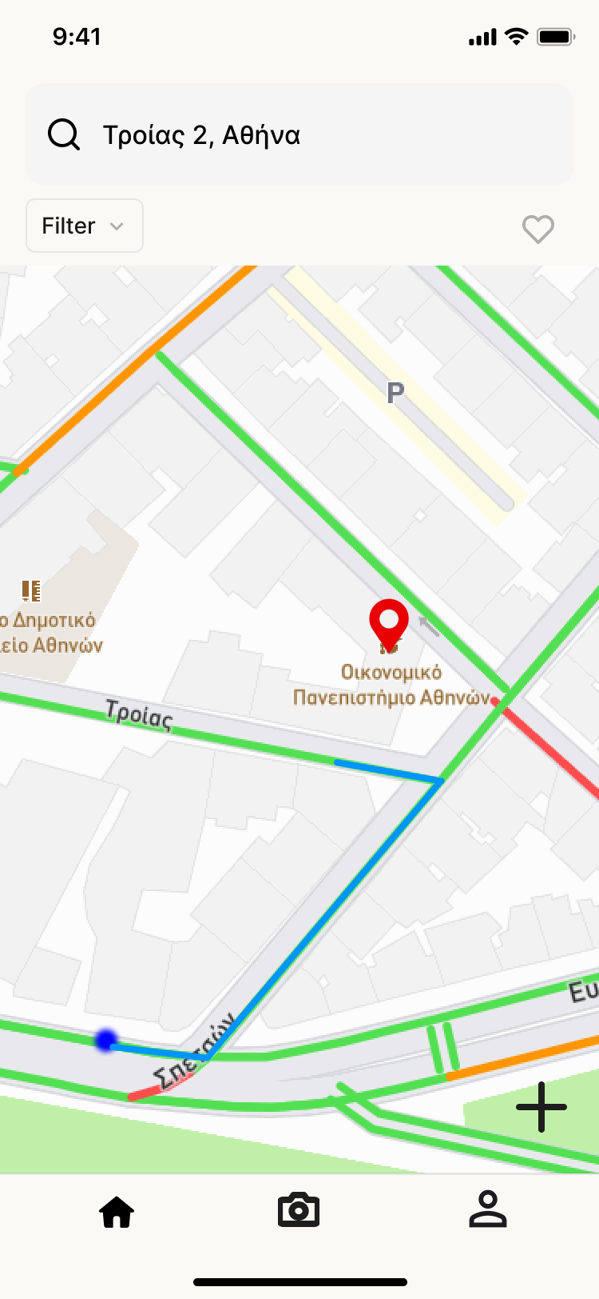

Access application mockups can be viewed at the following links:

- https://www.figma.com/design/G95SAz9UyBvHODPsz0b5VE/access?node-id=0-1&t=Wt9Vcs9tj6tx61Mz-1
- https://www.figma.com/proto/G95SAz9UyBvHODPsz0b5VE/access?node-id=1-3413&t=honinMQHZ7dLFMFp-1&scaling=scale-down&content-scaling=fixed&page-id=0%3A1&starting-point-node-id=12%3A1109

Assumptions:
- Users are willing to use a smartphone to plan accessible routes.
- Public authorities and businesses will collaborate to provide access to cross-checked accessible data.
- The necessary technology (map APIs, real-time updates, voice commands, adaptive interfaces) is available and can be effectively integrated.
- Revenue streams (ads, partnership etc.) will be sufficient to cover operational and maintenance costs.

Constraints:
- Complexity of integrating data from multiple sources (crowdsourced + official data).
- Challenges in maintaining data accuracy and ensuring information stays up to date.
- Need for strict compliance with data privacy regulations (like GDPR).
- High development costs, especially for designing custom interfaces for accessibility (e.g., voice commands, adjustable visuals).
- UX design challenges to meet the needs of users with various types of disabilities.

